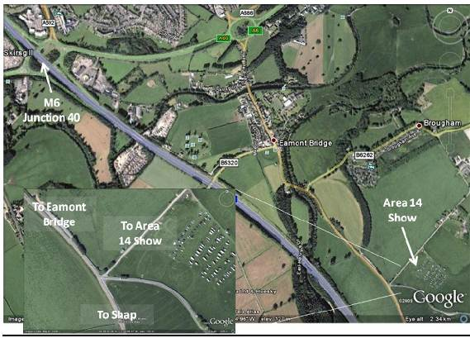

Directions

From the West, North & South
From the M6 Junction 40
Take the A66 towards Scotch Corner
At the next roundabout take the 4th ex it (A6 towards Shap) Follow the road through Eamont Bridge towards Clifton & Shap
Approx 1/2 mile past Eamont Bridge take the immediate (sharp) left turn onto the single track road.
After turning off to the left the entrance to the show field is approx 150m on the right hand side
There will be sign posts from the roundabout on the A66.

From the East
Take the A66 towards Penrith
At the first Penrith roundabout take the first exit (A6 towards Shap) Pollow the road through Eamont Bridge towards Clifton & Shap
Approx 1/2 mile past Eamont Bridge take the immediate (sharp) left turn onto the single track road.
After turning off to the left the entrance to the show field is approx 150m on the right hand side
There will be sign posts from the roundabout on the A66.

YOU CAN USE THE POSTCODE CA10 2DE AS A ROUGH GUIDE BUT PLEASE FOLLOW DIRECTION LATERLY AS THIS POST CODE MAY TAKE YOU UNDER A LOW BRIDGE

